Big Data Programming

## CSEE5590/490

**Lab 2 Report**

Submitted By:

Sneha Mishra:

Class ID: 11

Aditya Soman

Class ID: 19

Bilal Mustafa

Class ID: 13

## Links:

**Github:**

[GitHub Wiki Link](https://github.com/adityasomann/Big-Data-Programming/wiki/Lab-2)

**Youtube:** [Video Link](https://youtu.be/X2fB-CViSQc)

**HIVE**

**1. Get City with max "Excellent" Rating**

Query: Select max(address.city) from tomato where rating.text = "Excellent";

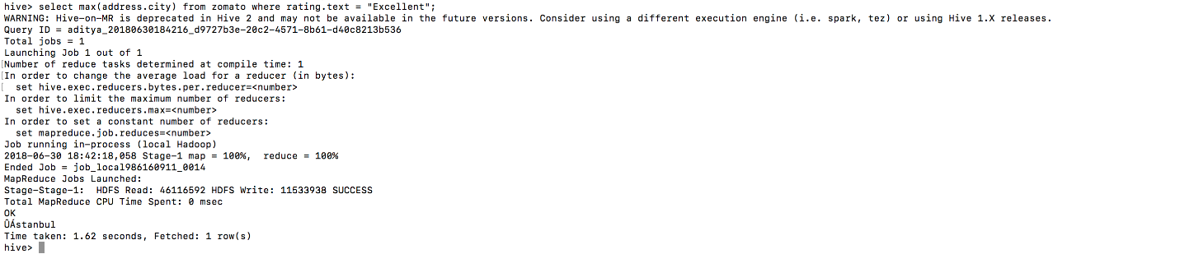

**2.** **Get count of cities that use Indian Rupees**

Query: Select count(address.city) from tomato where cost.currency = "Indian Rupees(Rs.)";

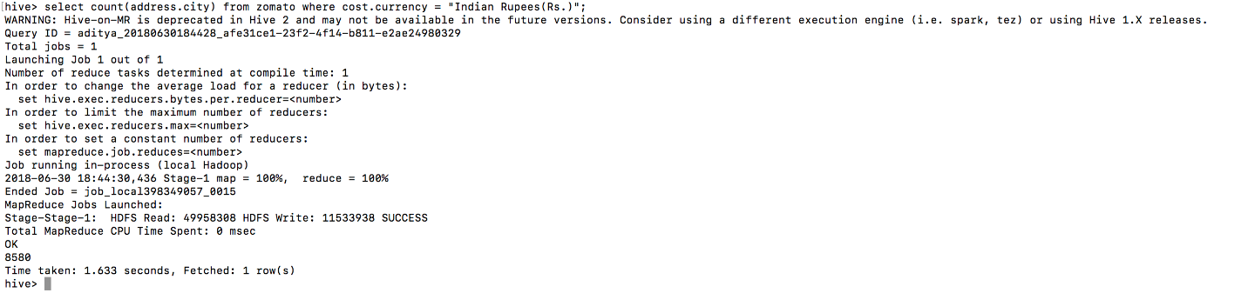

**3.** **Get the Costliest Restaurant Details**

Query: Select name, address.address, address.city, cost.avg_cost from zomato sort by avg_cost desc limit 1;

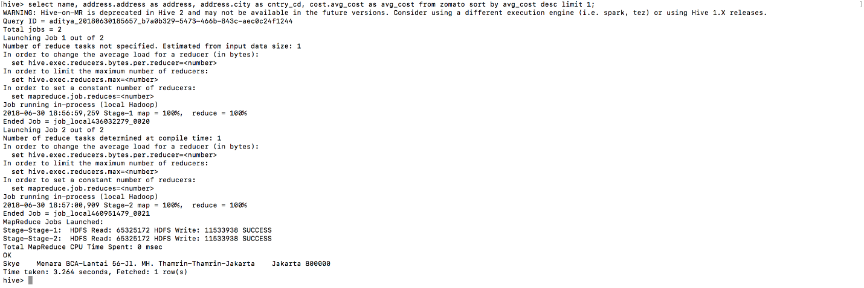

**4.** **Get the restaurant with the most number of votes**

Query: Select name, address.address, address.city, rating.votes, cost.avg_cost from zomato sort by votes desc limit 1;

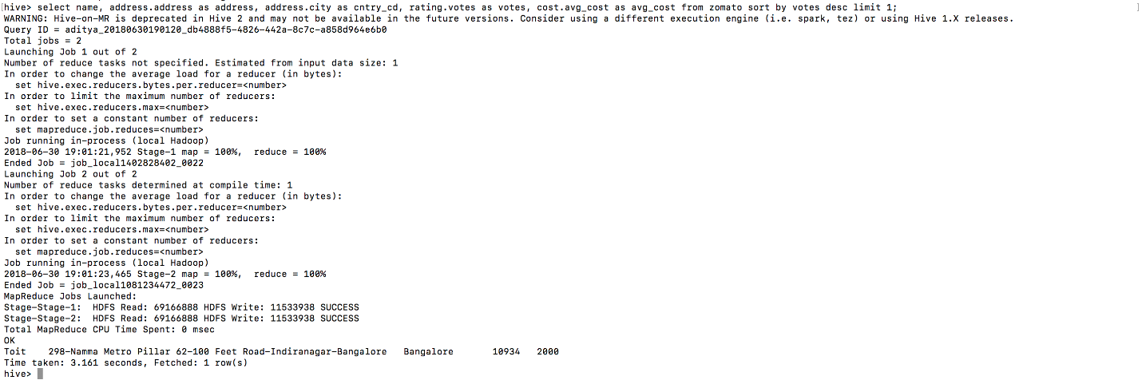

**5. Get the restaurant with the best customer satisfaction**

Query: Select name, addresss.address, address.city, cost.avg_cost, rating.text, cuisines from zomato where policy.table_booking = "Yes" and policy.online_delivery="Yes" and policy.delv_now="Yes";



**6.** **Get the Top 10 most recurring restaurants**

Query: Select name, count(*) as count from zomato group by name order by count desc limit 10;

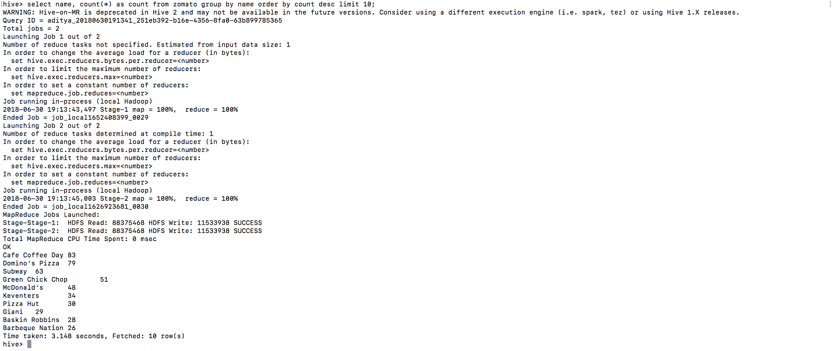

**7.** **Get all restaurants that offer French Cuisine**

Query: Select name, address.address, address.city, cost.avg_cost, rating.text from zomato where locate("French", cuisines)>0;

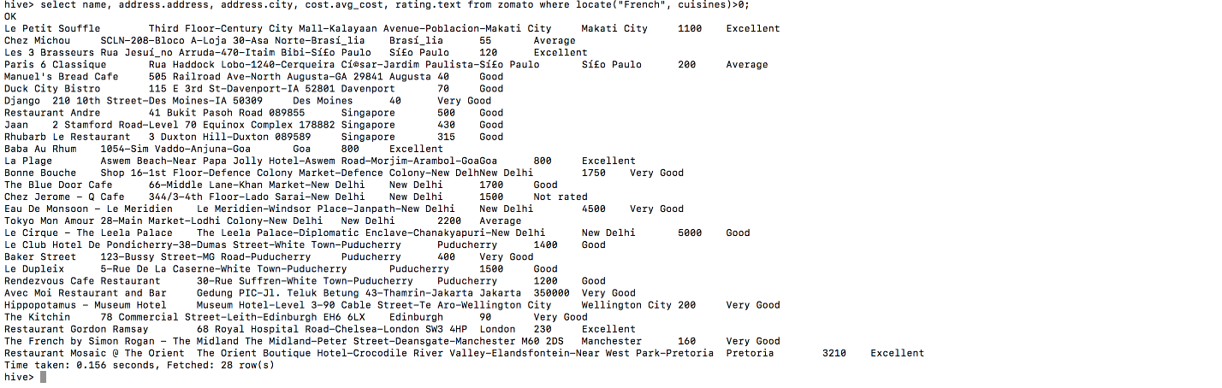

**8.** **Get Top 10 restaurants with "Excellent" rating and sort them by descending order of votes**

Query: Select name, address.address, address.city, cuisines, rating.votes from zomato where rating.text = "Excellent" sort by votes desc limit 10;

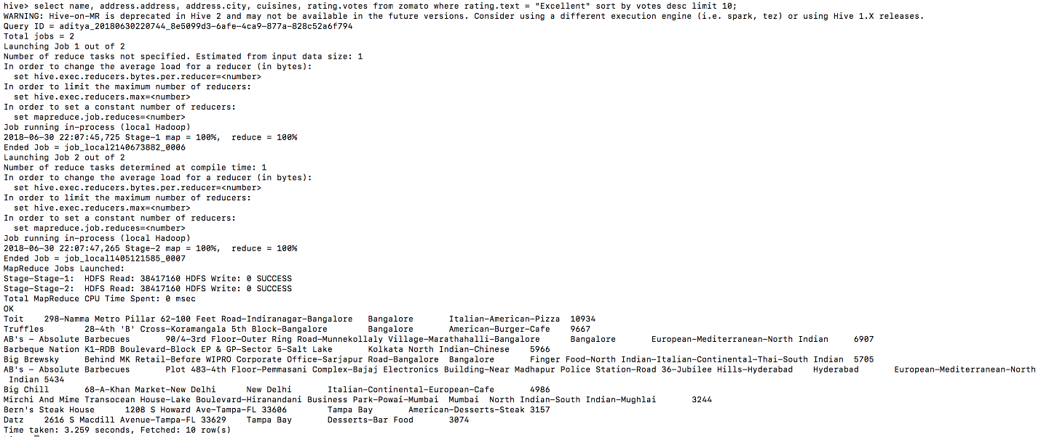

**9.** **Get Top 10 restaurants with high price range and "Excellent" rating and sort them by descending order of average cost**

Query: Select name, address.address, address.city, cuisines, cost.avg_cost from zomato where cost.price_range > 3 and rating.text = "Excellent" order by avg_cost desc limit 10;

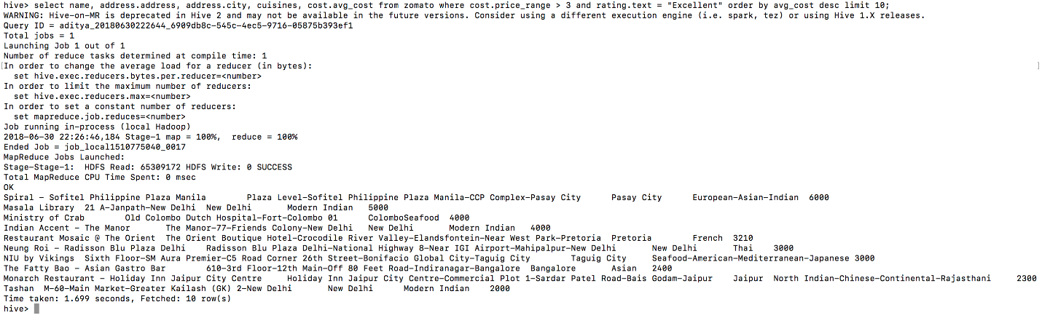

**10. Get Top 10 restaurants with high price range and "Poor" rating and sort them by descending order of average cost**

Query: Select name, address.address, address.city, cuisines, cost.avg_cost from zomato where cost.price_range > 3 and rating.text = "Poor" order by avg_cost desc limit 10;



**SOLR**

1. **Get all restaurants with Indian Cuisine**

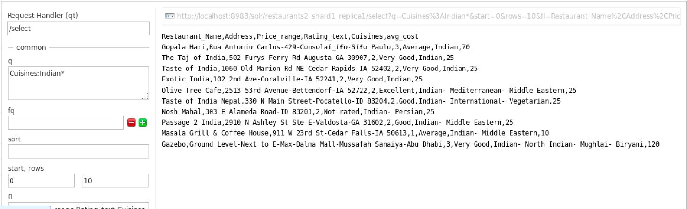

**2. Get the restaurant with the best customer satisfaction**

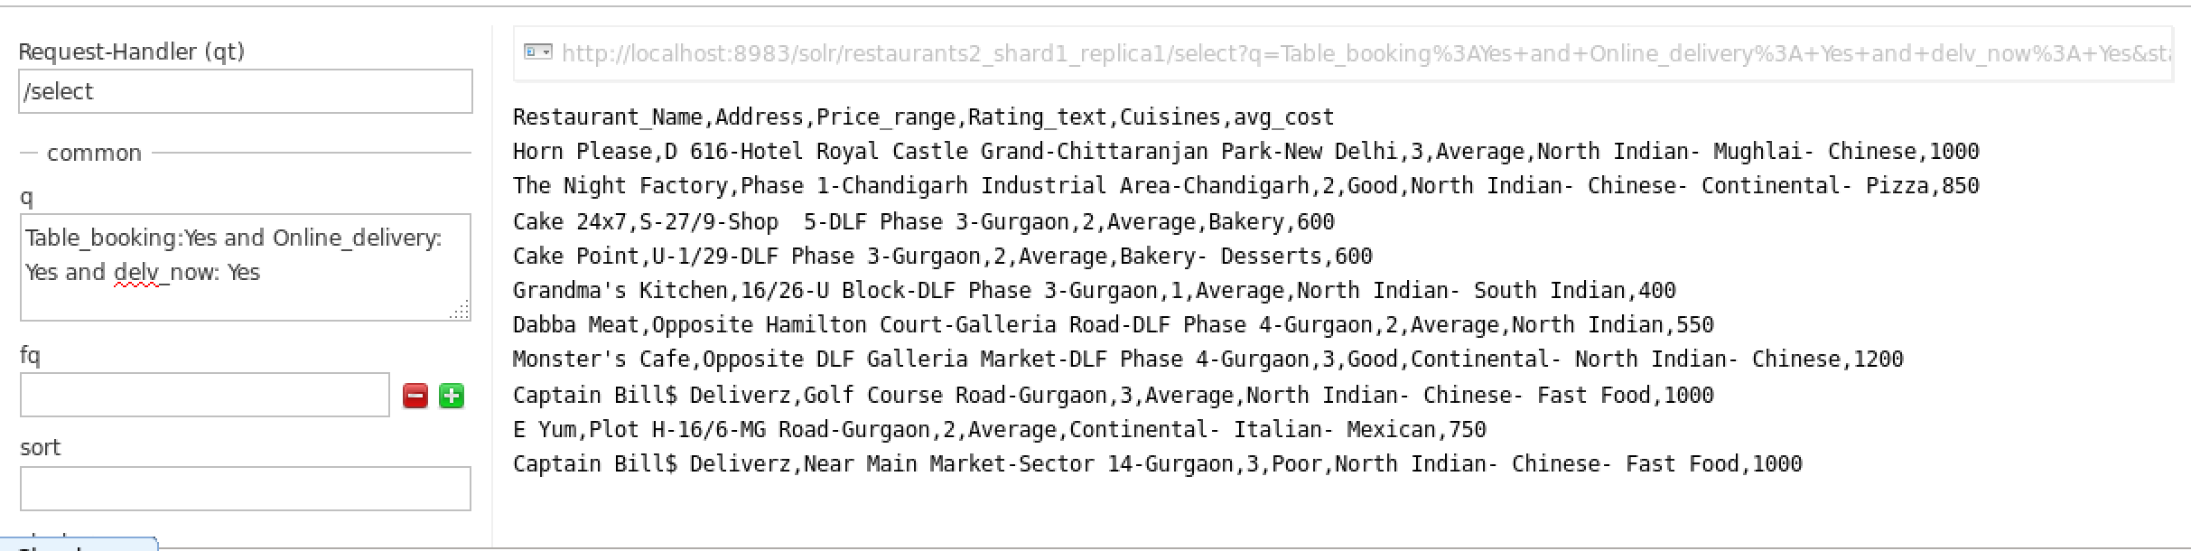

**3. Get the restaurants with "Poor" ratings but are expensive**

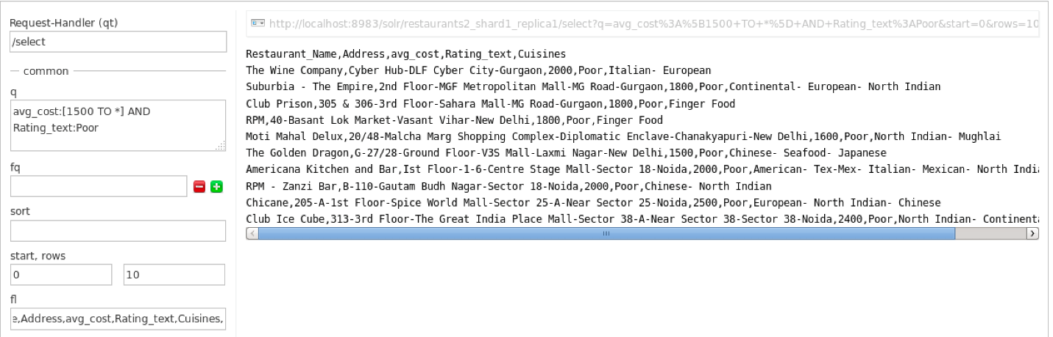

**4. Get the restaurant with "Excellent" ratings sorted in descending order of Votes**

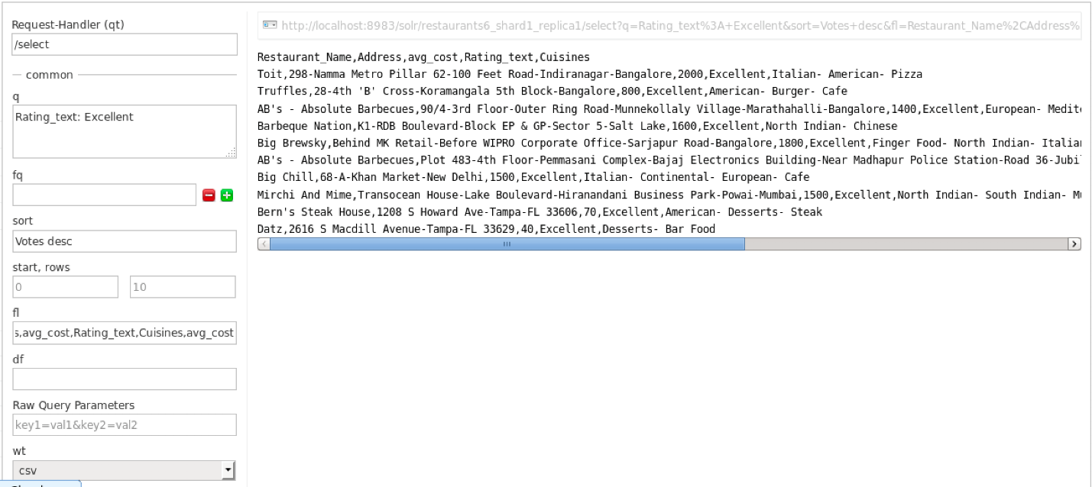

**5. Get the Top 10 restaurants which don'92t have "Excellent" rating but are expensive**

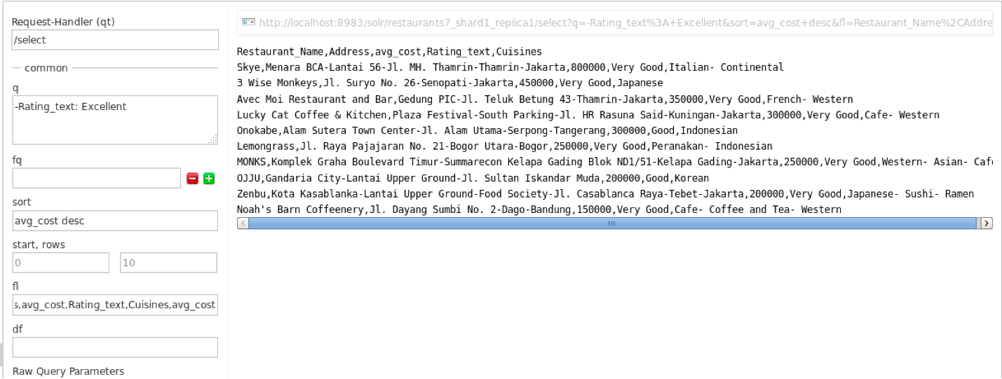

**6. Get the Top 10 costliest restaurants in the Northern Hemisphere**

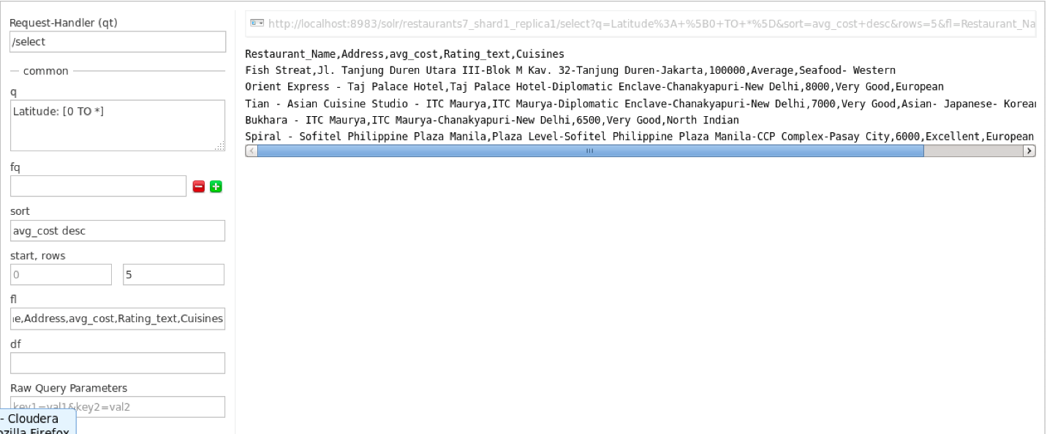

**7. Get the Top 10 most popular restaurants**

**Query:**

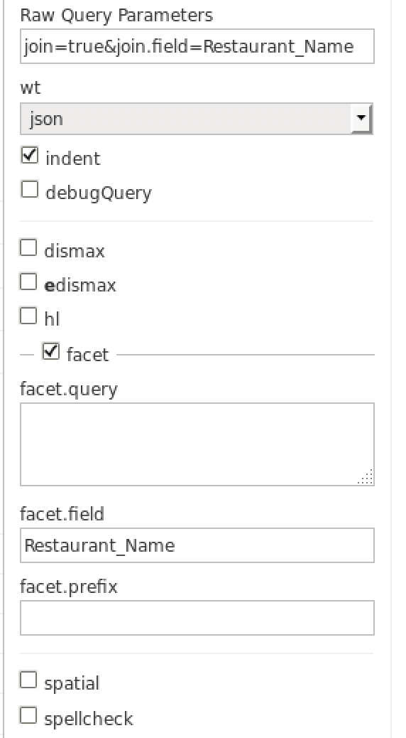

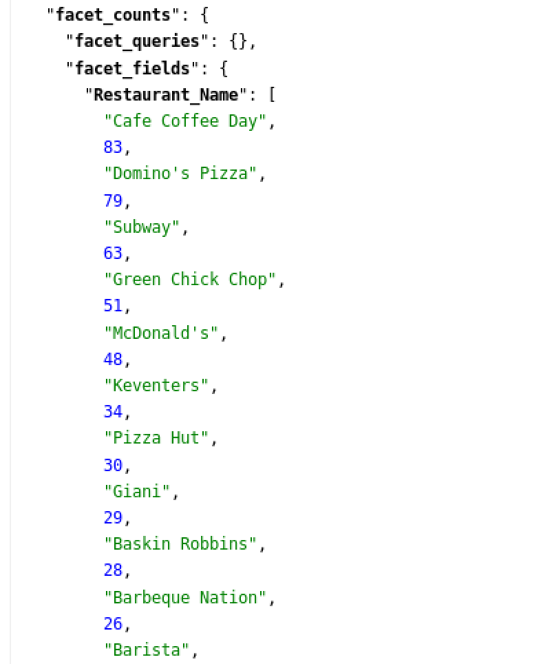

**8. Get Top 10 most commonly used currencies**

**Query:**

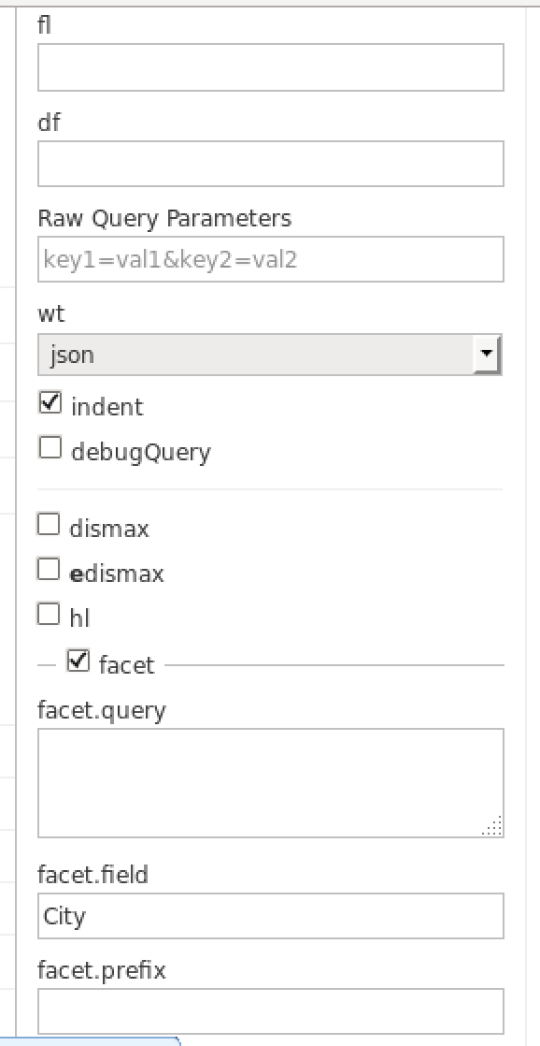

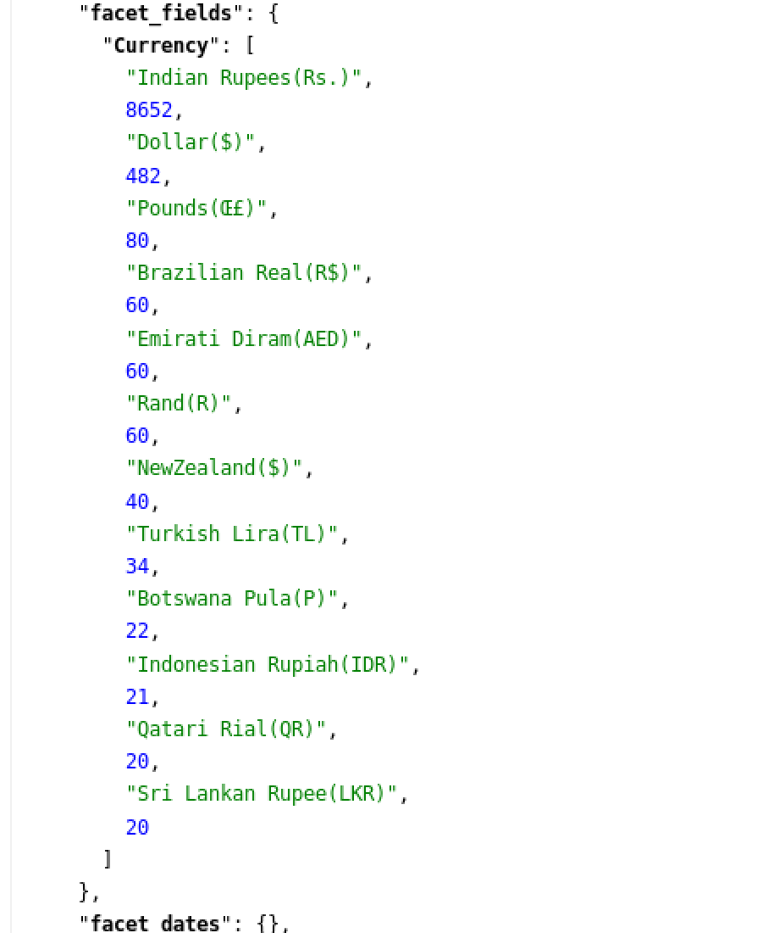

**9. Get the cities with the most number of restaurants**

**Query:**



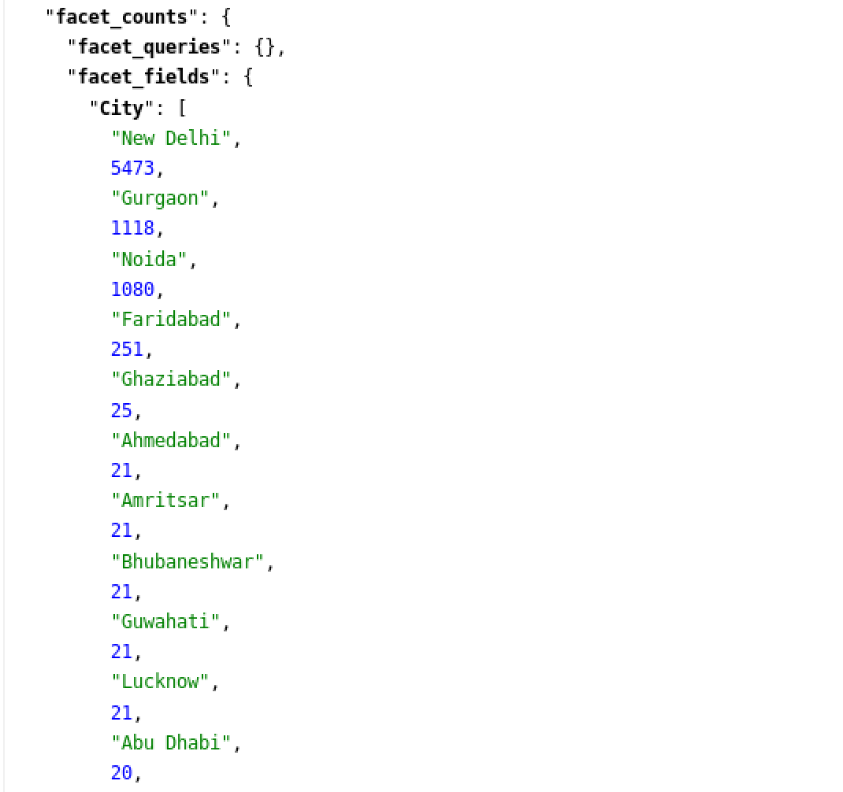

**10. Restaurants with the same locality**

**Query:**

